5. Performing basic CURD operation (create, update,read,delete) on db records.
1. CURD Operations in SQL

use DBMS;
show databases;
create table users(
id INTEGER PRIMARY KEY,
name TEXT,
email TEXT
);
show tables;

CREATE(insert a record)
insert into users(id,name,email)values('1','punam','dharmalepunam12@gmail,com')
,('2','sejal','pandesejal2@gmail.com');
select* from users;

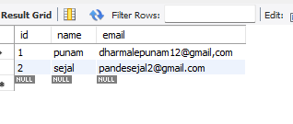
READ (retrieve data)
select*from users;
SELECT*FROM users WHERE id=1;

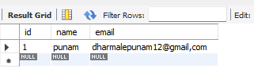

UPDATE (modify existing record)

UPDATE users
SET name='punam',email='dharmalepunam12@gmail.com'
WHERE id=1;
select*from users;
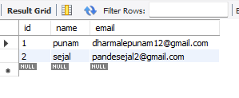

UPDATE( modify existing record)
UPDATE users
SET name='punam',emai1='dharmalepunam12@gmail.com'
WHERE id=1;
select* from users;
